# EXPERIMENT: 3

## To Design and implement full adder and subtracter using logic gates

**AIM:**Todesign andverify

1. Fulladder

ii. FullsubtractorusingbasicandNANDgates.

### LEARNINGOBJECTIVE:

* + Todesign,realizeandverifytheadderandsubtractorcircuitsusingbasicgatesanduniversalgates.

**COMPONENTSREQUIRED:**IC7400,IC7408,IC7486,andIC7432,PatchcardsandIC

TrainerKit.

### THEORY:

**Full-Adder:** The half-adder does not take the carry bit from its previous stage into account. Thiscarry bit from its previous stage iscalled carry-in bit. A combinational logiccircuit that addstwo data bits, A and B, and a carry-in bit, Cin, is called a full-adder. The Boolean functionsdescribingthe full-adderare:

S=(x⊕y)⊕Cin C=xy+Cin(x⊕y)

**Full Subtractor:** Subtracting two single-bit binary values, B, Cin from a single-bit value Aproduces a difference bit D and a borrow out Br bit. This is called full subtraction. The Booleanfunctionsdescribingthe full-subtracter are:

D=(x⊕y)⊕Cin Br= A’B+A’(Cin) + B(Cin)

1. **FULLADDER**

### TRUTHTABLE BOOLEANEXPRESSIONS:

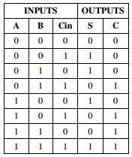 

### BASICGATES

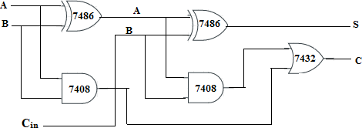

* 1. **NANDGATES**

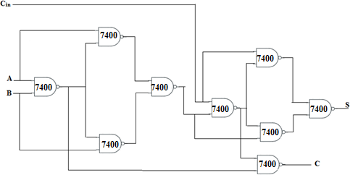

### FULLSUBTRACTOR

**TRUTHTABLE BOOLEANEXPRESSIONS:**

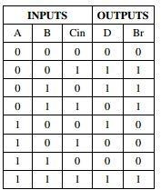 

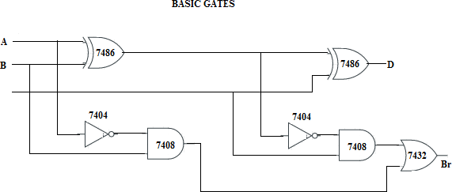

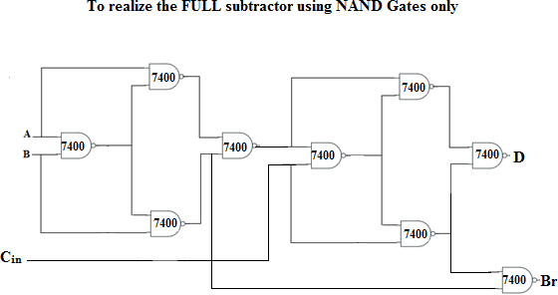

### PROCEDURE:

* Checkthecomponentsfortheirworking
* Inserttheappropriate IC intotheICbase
* Makeconnectionsasshown inthecircuitdiagram.
* Verifythe Truth Table and observethe outputs.

**RESULT: Hence we can say that both full adder & subtracter are verified and implemented successfully.**